Introduction: - Homes of the 21st century will become more and more self-controlled and automated due to the comfort it provides, especially when employed in a private home. A home automation system is a means that allow users to control electric appliances of varying kind. Many existing, well-established home automation systems are based on wired communication. This does not pose a problem until the system is planned well in advance and installed during the physical construction of the building. But for already existing buildings the implementation cost goes very high.

In contrast, Wireless systems can be of great help for automation systems. With the advancement of wireless technologies such as Wi-Fi, cloud networks in the recent past, wireless systems are used every day and everywhere.

* The Internet of Things: - In this age the gadgets that we're the utilization of are getting to be more brilliant and littler. they're connecting relatively without issue, and they might demonstrate to us that in almost every and everything of our regular daily existences. This new reality this is there inside the period—is alluded to as the net of things—it's miles about adapting to and gathering the enormous amount of certainties that we are capable 11 picking up from these developing networks of these hardware and sensors, which strategy such measurements, and furthermore share it with all the distinctive entomb related issues. it's miles a modern period, anyway we are plausible of having it with these now—found in keen sensors from our product associations, inside the security structures and inside nature we can control structures in our homes, and furthermore in our vehicle's capacities for self-observing.

For instance, practically different years from nowadays, our morning calendars might be really surprising and very well on account of the net of components advancement. Our alert may blast off sooner than its standard time because of the way that our local clever centre point may have analysed side interest conditions which could advocate an unmistakably moderate power for that day. The sensor for climate alerts nation high residue incorporate continually, so really case of your and world's sensitivity, you would safe house picked whether to put on a suit with sensors that would sing the character of air and after that prepared you to reasonable record of that may likewise trigger an ambush. Awesome advances in sensors, devices and (M2M) or machine to contraption network have made the basic web of things that are especially encouraging and furthermore have the limit epitomizing a phenomenal open entryway for big business that could make it go. Supervisor progresses in device to-gadget exchanges show implausible exchange.

The internet of things (IoT) is a computing concept that describes the idea of everyday physical objects

being connected to the internet and being able to identify themselves to other devices. It has dynamic global network infrastructure with self-configuring capabilities based on standard and interoperable communication

protocols where physical and virtual “things” have identities, physical attributes and virtual network and use intelligent interfaces.

* Dynamic and Self-Adapting: - IoT devices and system may have the capability to change dynamically depending upon the system and operating conditions or sensed environment.

For example, the surveillance cameras can change their modes based on day or night.

* Self-configuring: - IoT devices have self-configuring capability which allows large number of devices to work together to work provide certain functionality they can change their networking and update the software automatically.
* Interoperable Communication Protocol: - IoT devices can communicate with number of interoperable (Communicate with other devices without special effort) communication protocols.

Unique ID: - IoT devices have a unique identity differentiated with unique IP address.

* Integrated into Information Network: - IoT devices are integrated into the information network that allows them to communicate and exchange data with other devices and system.

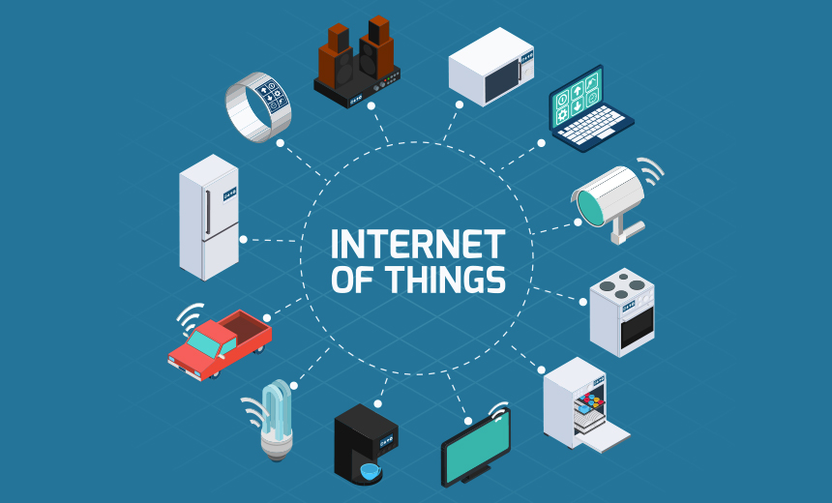

Why are Smart homes needed?

1. Savings- With all the connected electrical devices that are inclusive of getting to know coolers, sprinklers which might be clever, lights which might be wireless enabled, tracking the electricity retailers in addition to water heating and cooling modules that will also reduce energy and water use.
2. Control- Many of the today’s apparatuses in a household, from broilers and fridge to deadbolts and cooling gadgets, might be controlled naturally by means of projects in PCs, phones and pills. In many occurrences, the control of every one of these gadgets works when you are out of the house as well and can transform them, which implies you could close the entry via the air terminal, check at the pooch from any of the nation, or affirm that you turned off your stove from the commercial centre or some other store.
3. Convenience- Having the majority of your lounge and room lightings interchanged as you achieve your property remotely, the home theatre and TV machine consequently betting your favoured melody and the front entry opens naturally when you approach it with hands total of acquiring stuff, is maybe the end rich highlights of the astute and home. in any case, solace and harmony isn't about sumptuous and simple life, shrewd locks can likewise give you a chance to allow with the privilege of section of the particular people at exact examples and not generally, so you don't must remain at home as well as supply out a key. so also, a sensor lets you know while your fridge vacant or out of stock encourages you to "arrangement" your entrance or leave entryway from wherever inside this world.
4. Security- They are so clear, connected responses for wellbeing for the sharp home that are sensibly estimated choices for each checking security verified frameworks. remote empowered cctv cameras, associated development sensors notwithstanding astute smoke cautions might be observed from interior or outside a local utilizing a video live, electronic mail and ready writings.
5. Safety- Sensors that are verified that can discover spillage of water, phase of stickiness, carbon dioxide, development, warmness and each ecological issue that could be envisioned assistance keep occurrence from transforming into catastrophes as they could speak with proprietor legitimately, on each event you're, wherever you need. Senior autonomy Automate sound update notwithstanding voice actuated ready frameworks are just a group of the elements of local mechanization that help seniors' have free existence for a greater drawn-out timespan. moreover, cameras connected to the Wi-Fi with - way report may furthermore help friends and family hold a watch on the senior inhabitants when they can't go and real beware of them.

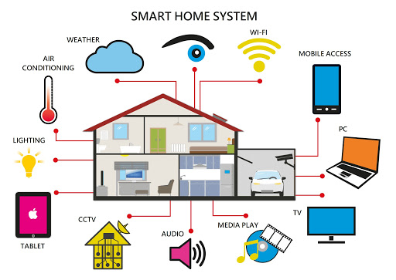

Problem Statement: - In these present days home computerization is persuading the chance to be vital to improve our life conditions. Comfort and straightforwardness of utilizing home machines is the thing that home robotization is progressing. Home robotization offers a bleeding edge lifestyle in which an individual finds the opportunity to control his whole house utilizing a pushed wireless, from turning on a TV to locking/opening sections; it in like way offers a competent utilization of centrality. Home automation systems face four main challenges, these are high cost of ownership, inflexibility, poor manageability and difficulty in achieving security. By the by, to get or verify such framework exhibited will cost a great extent of cash and that is the authentic reason of why home computerization has not gotten much premium and thought, adding to that in like way the multifaceted thought of displaying it and engineering it. Therefore, it is essential to bode well and simple to organize, in the event that this is allowed to individuals, they will gain it in their homes, workplaces and schools. In a way, a framework alteration for the home computerization is required with the genuine goal to chop down the cost of applying it to houses. The main objectives of this research are to design and implement a home automation system using IoT that is capable of controlling and automating most of the house appliances through an easy manageable web interface. he proposed system has a great flexibility by using Wi-Fi technology to interconnect its distributed sensors to home automation server. This will decrease the deployment cost and will increase the ability of upgrading, and system reconfiguration. In addition, home computerization offers ease of cerebrum and body to injured or potentially progressively settled individuals in their homes by only a single tick to do what they require as imparted as of now.

OBJECTIVES: -

1. To assembling a remote home robotization structure constrained by gadget associated with the web.
2. Test the set up and analyse the data: After the system is set-up, with the help of a mobile phone and a controller, tests are driven while data is recorded and inspected.
3. To arrangement and execute monetarily adroit home robotization structure yet a capable one.
4. To plan an easy to use and a guaranteed structure to control home machines particularly planned to support the more prepared individuals and weakened.
5. To have better control over your living environment and increase your freedom
6. To have better control over your living environment and increase your freedom
7. To make it easier to communicate with family members.
8. To improve personal safety
9. In the event of an emergency, it will function as a visual warning system.

Advantages of Home automation: -

In recent years, wireless systems like Wi-Fi have become more and more common in-home networking. Also in home and building automation systems, the use of wireless technologies gives several advantages that could not be achieved using a wired network only.

1. Reduced installation costs: First and foremost, installation costs are significantly reduced since no cabling is necessary. Wired solutions require cabling, where material as well as the professional laying of cables (e.g. into walls) is expensive.
2. System scalability and easy extension: Deploying a wireless network is especially advantageous when, due to new or changed requirements, extension of the network is necessary. In contrast wired installations, in which cabling extension is tedious. This makes wireless installations a seminal investment.
3. Aesthetical benefits: Apart from covering a larger area, this attribute helps to full aesthetical requirements as well. Examples include representative buildings with all-glass architecture and historical buildings where design or conservatory reasons do not allow laying of cables.
4. Integration of mobile devices: With wireless networks, associating mobile devices such as PDAs and Smartphones with the automation system becomes possible everywhere and at any time, as a device's exact physical location is no longer crucial for a connection (as long as the device is in reach of the network).

For all these reasons, wireless technology is not only an attractive choice in renovation and refurbishment, but also for new installations.

Disadvantages of Home automation: In the world of technology, new developments can be so fast that predicting what may happen in the future can be redundant as it appears as soon as it is predicted. Although the future of smart home is definitely bright but we need to take a holistic view of these developments, understanding negative effects that such growth creates.

1. **Security Issues**: -As with all computing devices, security will become a greater issue as more people use smart home devices. Certainly, there will be a range of security concerns that arise and a subsequent mushrooming of smart home security software and devices.

**a) App security**: - Smart home devices are usually linked to companion apps that can be used to control the devices. However, to do this they are granted a range of permissions that influence the functionality of the device, such as being able to open and close a smart lock that is securing your home.

If hackers gain access to these apps, then it could have considerable security implications, as they will be able to control access to your home. The best way to  
mitigate against this is to ensure your smart home apps are as up-to-date as possible and that you install any software & security updates that become available for the apps.

**b) Wireless security**: - Almost all smart devices derive their functionality from some form of wireless communication (Wi-Fi or Bluetooth). As with all digital communications, there is potential for hackers to intercept wireless communications and use this to gain access to your smart home devices. Wi-Fi is one of the most common ways to connect to smart home devices, so it is important that you protect your home Wi-Fi router as well as you can.

**c) Integrated systems**: -Some manufacturers offer integrated smart home systems, where one system is used to control all of the smart home devices. The obvious risk here is if hackers gain access to the system, then they can control everything in your smart home.

**2. Cost:**

1. **Extremely expensive**: -Although a lot of smart home devices are now affordable for many, but still, it is extremely expensive to fully equip a home with smart devices. However, most computing technology becomes progressively more powerful & less expensive and   
   this will be undoubtedly applicable for smart home devices as well.

3. **Greater acceptance**: - A lot of new technology can sometimes be seen as unnecessary & some people may currently view smart home devices in this way. But in the same way that, over the years, we have seen devices such as washing machines, microwave ovens & TV remote controls become indispensable in the home, it is probable that in a few years, no one will question the fact that they control their lights with a voice command or  
clean their home with a robotic vacuum cleaner.

Attacks on smart home devices are not unheard of, but they are relatively rare. It is a personal choice to weigh up the security & financial risks against the range of benefits that smart home devices offer.

Methodology: -

In order to implement smart home, I used new released cisco packet tracer, which included different smart object used for home automation such as smart fan, smart window, smart door, smart light, smart garbage door, fire sprinkler, lawn sprinkler and different sensor is included.

To control this smart object and sensor, microcontroller (MCU-PT) and Home Gateway used, since it provides programming environment for controlling smart object connected to it and provide controlling mechanisms by registering smart device to Home Gateway respectively.

Home Gateway: - Home Gateway have 4 Ethernet ports in addition to a wireless access point configured with the "Home Gateway" SSID (see fig 2). To secure wireless connection WEP / WPA-PSK / WPA2 enterprise can be configured on home gateway. The figure 2 shows seven internet of Things device connected to a Home Gateway by using Ethernet cable and wireless. To connect the Home Gateway to the Internet its Internet WAN Ethernet port available on home getaway. The IoE device can be remotely managed through a web interface hosted by the Home Gateway. The Home Gateway internal (LAN) IP address is 192.168.25.1 but it can also be accessed through its Internet facing IP address.

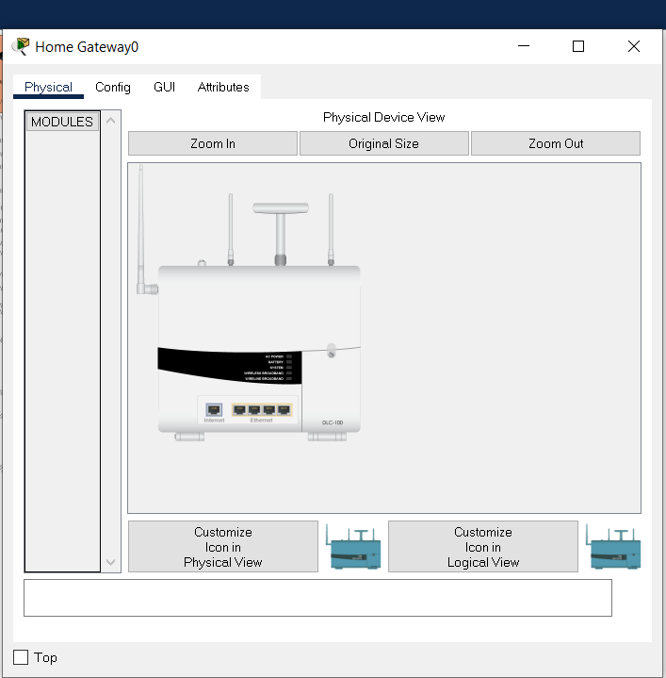

Home gateway ethernet and internet port

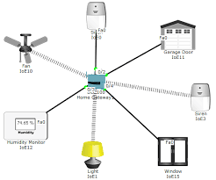

Seven smart things connected to Home Gateway

The above figure shows the smart object is connected to the home Gateway using Ethernet cable and wireless medium to manage smart device local and remotely. Home gateway also works as DHCP server by assigning IP address to each smart device that connected to it.





The above figure shows after registering smart device to home gateway all device are accessed through web by legitimate user.

Implementation: - To implement smart home using cisco packet tracer I used different sensor, smart device and detector to make smarter. The following figure represent the home architecture that connected each other using wireless and wired medium.

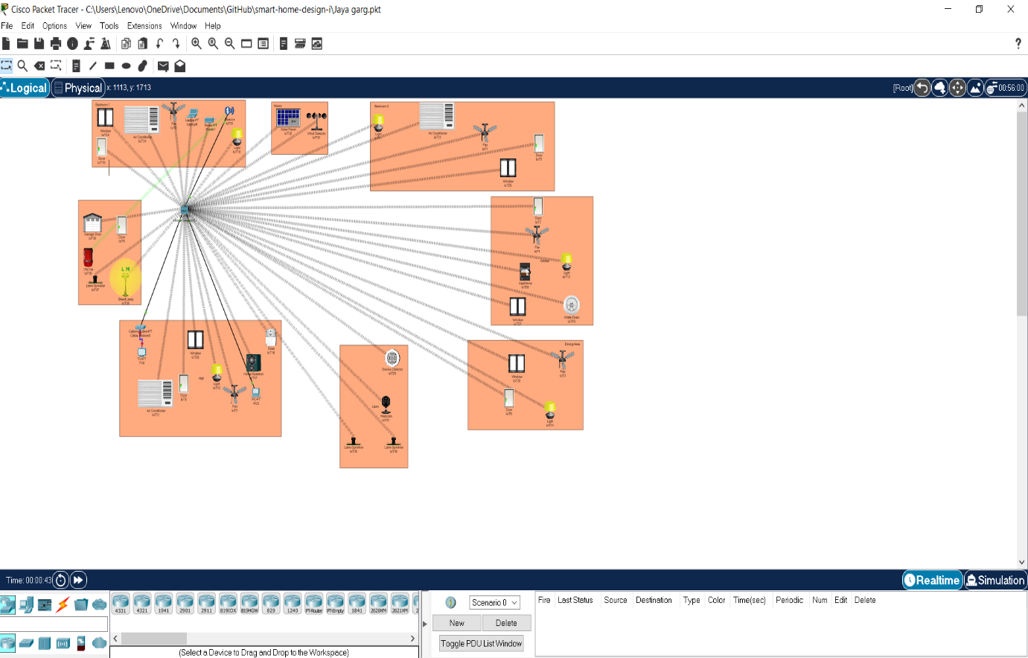

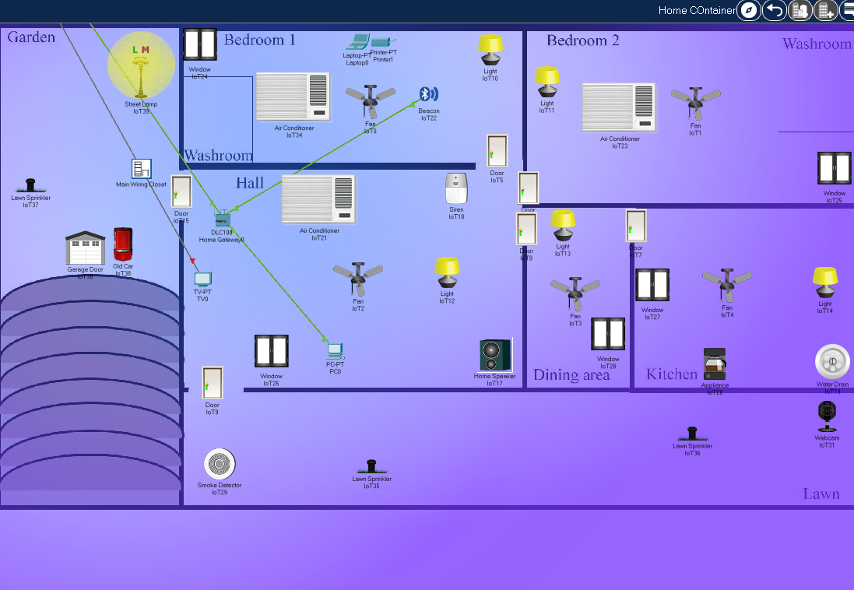

Conclusion: - I implemented smart home using new released cisco packet, because this version included different IOE device used for home automation. I used home Gateway to register smart device on it to control them and Microcontroller (MCU) to interconnect different sensor and IOE device. Also, MCU provide programming environment to manage different device, different programming language available on MCU but I used JavaScript and python to control the device

Future Scope/Work: - Using this system as framework, the system can be expanded to include various other options which could include home security feature like capturing the photo of a person moving around the house and storing it onto the cloud. This will reduce the data storage than using the CCTV camera which will record all the time and stores it. The system can be expanded for energy monitoring, or weather stations. This kind of a system with respective changes can be implemented in the hospitals for disable people or in industries where human invasion is impossible or dangerous, and it can also be implemented for environmental monitoring.